Meeting room
If you wish to be able to book a meeting room yourself, install Resource Finder from the Software Center on your PC or ask IT for assistance.
Please note, meeting rooms are only intended for meetings NOT teaching.
You find resource find resource finder in the top bar of meeting invitation.
The meeting rooms at the Department (V, M and H) are on page 5.
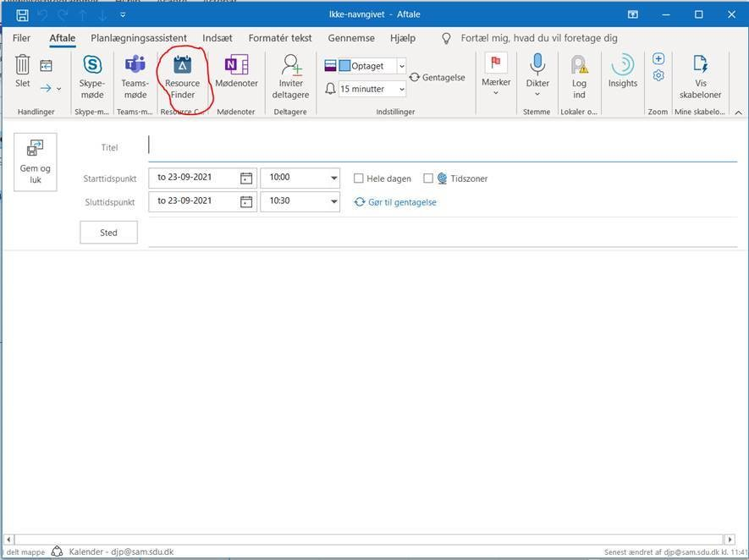

The secretary dedicated to your section will still be happy to provide you with the service if booking rooms, incl. the library, Agora and V, which it is not possible for you to book via Recourse Finder.

