Welcoming pamphlet to new Postdocs and Assistant Professors at the Department of Political Science and Public Management, University of Southern Denmark
Updated May 2023
Contents

Introduction 1
Who to go to? 2
Mentoring programme 2
Lecturer Training Programme (LTP) 2
Work duties (Norm hour system) 3
Employee development dialogue 3
Employee ID, library card, and your pigeonhole 4
Budget plan and credit card with corporate liability 4
Conferences 5
Social activities & work/life balance 6
Parental leave 7
Funding 7
Research Ethics Committee (REC) 8
Data Security and Protection (GDPR) 8
Miscellaneous 9

Introduction
Congratulations with your new position as a Postdoc or Assistant Professor. Like starting in any job, starting at our department naturally entails a lot of questions, uncertainties, and practicalities to be figured out. This short welcoming pamphlet is a condensation of the experiences made by senior and previous Postdoc colleagues about questions that typically come up in the first couple of months after starting as a Postdoc or Assistant Professor. Of course, the list is in no way exhaustive. So, don’t hesitate to knock on the door of your colleagues and ask.
The employee handbook is a very useful resource, it includes information about topics such as strategy, policies, management and organisation: https://sdunet.dk/en/enheder/institutter/is/medarbejderhaandbog

Who and where to go to?
Generally, anyone in the department will be more than glad to help you out in case you have any problems. However, as the department is structured in different sections, your colleagues in your respective section will be most likely to help you out. Additionally, we have established a Postdoc/Assistant Prof group at the departmental level where we meet regularly during the semester to discuss pressing issues, provide helpful information, or simply talk about our recent successes or failures to share experiences.
General info about the department and who to go to: https://syddanskuni.sharepoint.com/Sites/statskundskab/SitePages/Home.aspx?web=1
The IT department at SDU: https://www.sdu.dk/en/om_sdu/faellesomraadet/sdu_it/kontakt_os
Find a campus map with markings for Dept. of Political Science, IT helpdesk for employees, café, Canteen and light-rail stop at the bottom of this document.
Online campus map with search functions (though not entirely intuitive): https://clients.mapsindoors.com/sdu/573f26e4bc1f571b08094312/search
Trade Union at School of Business and Social Sciences
If you have issues concerning salary, employment conditions or management decisions, you can reach out to a union representative (regardless of whether you are in a union or not). You can find a list of union representatives here (only in Danish).

Mentoring programme
The department has started an internal mentoring programme in which you can pick a mentor, most often from within your section. This can be immensely helpful as they can be your go-to persons to help in case you encounter operative or strategic challenges or questions regarding teaching, research, networking etc. We highly recommend that you pick one. Typically, the mentoring programme will begin with your mentor setting up an informal meeting with you. At this meeting, you can introduce yourselves to each other, you could read through this welcoming pamphlet together to clear out any uncertainties or you may just want to get to know each other better. Setting up small informal meetings on a regular basis, approximately once a month, should build up a mentoring relationship in which the mentor encourages and supports you, and where both social and academic ideas and advice can be shared.
You should feel free to email your mentor any questions or concerns you might have in your new position, and you may expect your mentor to provide you with good advice and share with you his/her own experiences and perspectives. The mentor will hopefully help you adapt to your new working environment, gain insights to social and professional cultures, and deal with work/life balance.

If you haven’t been offered a mentor, contact the leader of your section who will help you to it.Lecturer Training Programme (LTP)
LTP is a programme which aims at strengthening the participants' educational and pedagogical skills. The programme is mandatory for newly appointed assistant professors at SDU. If you are a postdoc, you need special permission from the department or your project leader to apply for the LTP.
The Lecturer Training Programme runs over two semesters, requires approx. 270 hours of work by the participant (10 ECTS). The Lecturer Training Programme starts up in December and June each year. Deadline for registration is 15 October and 15 April, respectively.
For more information follow this link: https://www.sdu.dk/en/om_sdu/institutter_centre/c_unipaedagogik/universitetspaedagogikum
Contact information regarding LTP: https://www.sdu.dk/en/om_sdu/institutter_centre/c_unipaedagogik/kontakt
Resources regarding teaching: https://www.sdu.dk/en/om_sdu/institutter_centre/c_unipaedagogik/ressourcer

Work duties (Norm hour system)
Work duties at the department are tracked and monitored using the so-called norm hour system. Within this system, every employee has a certain budget to fulfil each semester. Assistant Profs have a budget of hours per semester. See details here.
Post docs are not a part of the norm system, but in some cases, they might have made an agreement with the management that they are, e.g. in connection with their employment or an extension.
Predominantly, the work duties consist of teaching responsibilities. But they can also be, for example, supervision, administrative tasks, the Lecturer Training Programme, or Danish classes (for foreigners). Furthermore, you can get a “buy out” if you secure external funding for research projects. This work is planned in cooperation with your Head of Section. For more information on work duties and the norms for different task, see this outline.
This system is used as a more general monitoring tool to make sure that (teaching) workload is distributed more or less evenly. So do not stress out too much if you do not use your entire budget in the beginning. However, be aware that your Head of Section might approach you in case there are any unforeseeable changes in the teaching schedules and ask you to help out instead of your colleagues that have a severe surplus.

Employee development dialogue
A few months into your new employment, and again approximately one year later, you should expect an employee development dialogue (in Danish often simply called “MUS”) with your Head of Section. Before the interview you will get an email with the topics and a list on optional topics that you might want to put on the agenda. The interview is a formal conversation between you and the Head of Section to evaluate your progress and plan the development of your skills, while you are a Postdoc or Assistant Professor at the Department of Political Science and Public Management. The interview is strictly confidential and is designed as an opportunity for you to voice any concerns of any kind, be they social or professional. The last of these interviews has an additional focus on your career opportunities upon completing your dissertation.
You should see this dialogue as an opportunity to pick strategic goals you want to pursue during the next year, while agreeing with your Head of Section on how the section might support you along these goals. There are no formal consequences if you fail to fulfil these goals, so you do not have to worry about selecting more ambitious goals to work towards.

Employee ID, library card, and your pigeonhole
When you arrive, you will receive an employee ID card. The employee ID is your key to the department outside normal working hours. You can also use your employee ID for collecting print jobs at the printers. If you experience any troubles, please contact Tina Guldbrandt Jakobsen (tja@sam.sdu.dk). Together with your employee ID, you will also receive instructions about how to activate the ID card by making a four-digit code at the card reader by any of the university entrances.
You can also use your employee ID card to borrow books from the university library, and you can access the library’s digital sources by using your SDU login information. This can be done at the library or online. If you want, you can have the library send the books, you request, to your pigeonhole at the department. Note, that using your employee ID card works after the first salary is paid, only. That is, after the first month has passed. You can, however, contact the library directly if you need access to during the first month.
Each employee has their own pigeonhole. You can find it in the ‘postrum’ at the floor level in the left wing (see map).
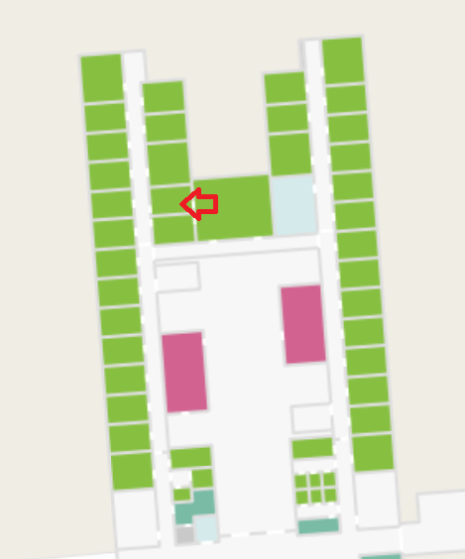

Budget plan and credit card with corporate liability
Generally, you get financial support for almost all of your necessary expenses by your section’s budget. This includes conferences, travels, books etc. Data collection is normally not covered by this budget (see Funding section for more information on this). The budget is shared among all members of your section, so be aware that your Head of Section has to balance various requests and demands.
When you order and buy books abroad, you should use a credit card with corporate liability. You order a credit card with corporate liability by filling out an application form, which has to be signed by the Head of Department, and then handed to Ann Skovly. Ann will then forward the form to the Travel Office. You will find the form here. The rules for using the credit card can be found here.
When buying books in Denmark, you must state the Department’s EAN number and ask for an electronic invoice, with your name as the reference. The Department’s EAN number is 5798000423312.
Buying media stuff
Books can be ordered according to SDU’s general agreement:
- iMusic (Audio Visionary Music): Publications from not-Nordic countries
- BibMedia: Publications from Nordic countries
Nordic countries are Denmark, Norway, Finland, Iceland, Sweden, The Faroe Islands, Greenland and Åland.
iMusic hence delivers books coming from a publishing company with headquarters in a not-Nordic country, whereas BibMedia delivers books coming from a publishing company with headquarters in one of the above-mentioned Nordic countries.
It is prescribed for all purchasers at SDU to buy books according to the agreements. If the suppliers in the framework agreements cannot deliver the desired publications, you can make your order at an alternative supplier. This would be an exception to the general rule.
The framework agreements became effective on the 1st of November 2020; hence all book procurements should now take place according to the agreement with iMusic and BibMedia.

Conferences & Traveling
Attending and presenting at conferences is a good way to get feedback on work in progress and to build an (international) network. Naturally, the department supports you in these activities. Aside from your research field-specific conferences, is the Annual Meeting of the Danish Political Science Association a great venue (typically held in late October, with a deadline for submissions in May). Especially for Postdocs and Assistant Profs from outside Denmark, this is a very productive, high-quality, yet friendly and ‘hyggelig’ conference to get to know your Danish peers.
Make sure to draw up a budget for the conference, including conference fees as well as hotel and transport costs, and send this plan to your Head of Section before booking anything. Normally, the budget suffices for all section members to participate in the conferences they want to.
Plane tickets must be bought through CWT.
To get your other costs reimbursed, you have to register them in the zExpense reimbursement system. Additional information regarding the booking process and reimbursement system can be found here.

Language revision
We have a Language Services Unit at SDU: https://sdunet.dk/en/servicesider/kommunikation/sprog_og_oversaettelse/oversaet
To pay for language revision, you make a request to your head of section with a budget. You can find the rates at their webpage where you also fill in a short form.

Social activities & work/life balance
As a new employee —especially if you have not been affiliated with the department beforehand—it can be difficult to decode which social activities you are expected to participate in (though they are voluntary). These issues are quite important for establishing and maintaining a good relationship to your workplace and your colleagues, but exactly how you go about it depends mainly on your own sensibilities. This is not meant to be a checklist of things you must do, but, rather, it is a collection of things you may not be aware of and some experiences from fellow PhDs.
Starting with social activities, there are quite a few of these during the year; some of them are arranged by the department, some by your section, some by other groups you may be affiliated with (course group etc.). You are of course free to choose which (if any) of these you wish to participate in, but we encourage you to attend at least the Christmas party arranged by the department. Aside from being great ways to get to know your colleagues in an informal setting, these events also serve to bolster a sense of belonging—it may seem trivial but are actually quite important.
Apart from these occasional social activities, there is a tacit norm that employees should be present in the everyday life at the department. If you don’t live in Odense or in the local area, or if you have small children, it is of course not expected that you show up every day at 9, but we encourage you to be present as much as possible, and to keep your office door open (general open-door policy). It will be much easier to fit into the department this way. Please refer to the department’s staff policy for the specific policy on presence and working hours. All employees are expected to note their presence at SDU on the office window.
The work/life balance is a sensitive and highly personal matter, but it is our experience that eventually you will feel that balance tip to the negative side. We therefore feel that it is important to be frank about the issue. Do not feel pressured to work more because you see others burning midnight oil. If you are in doubt whether you are progressing as you should (and we all have these doubts), check with your mentor or colleagues. These are much more reliable measures than the work hours put in by others. Remember, you are employed to work an average of 37 hours every week and you have 5 weeks of holidays to spend as you please. This is what your contract states, so you are well within your rights to work no more than this.
Especially if you are from a non-Danish background, you will notice that there is no informal competition about who stays the longest at the office. We find that this takes away a lot of artificial stress and pressure. Especially in academia, you have a lot of autonomy and it is up to your responsibility to make use of this autonomy the way it best suits your individual routines and preferences.

Parental and other types of leave
As a Postdoc or Assistant Prof, you are entitled to parental leave under the prevailing terms and conditions. You are not expected to partake in the working life at the department during parental leave. Obviously, it can be difficult to leave your project for a longer period, and therefore the department has implemented a set of options for fixed-term employees, including Postdocs and Assistant Profs. Details about this, and about days off for moving, care days, leave for sick kids are outlined in the department’s staff policy.

Funding
Research Support at Business and Social Sciences supports the faculty’s academic environments in all aspects of external research funding – from guiding through the national and international funding landscapes, to advising on specific funding strategies and assisting throughout the application process.
Research Support assist and advice on:
- Project applications from start to finish
- Identification of relevant calls and foundations
- The design and readability of competitive project applications

If any questions – large or small – regarding external funding, don’t hesitate to reach out to either the secretariat at the department or Research Support:
https://www.sdu.dk/en/om_sdu/fakulteterne/samfundsvidenskab/forskning/forskningsstoette

Research Ethics Committee (REC)
While there is no formal requirement at Danish universities in political science to receive ethics clearance for research projects, there might be occasions where you need approval from an IRB (institutional review board) anyway, e.g., some journals or funding agencies might require an approval. Sometimes, you might just want to be safe.
If so, there is a well-structured and supported process in place. You can find general information like who is currently member of the board, when will the board next meet and potentially discuss your application here. The general process looks like this:
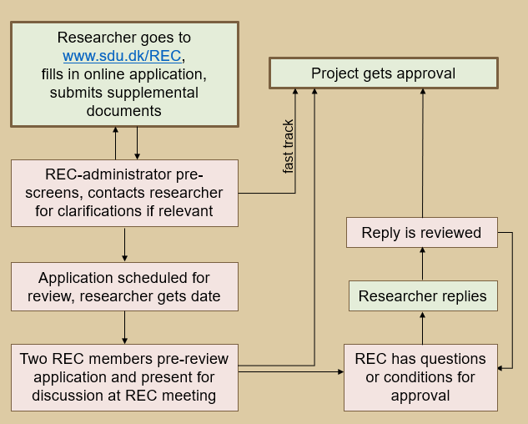
Normally, the process takes about two months, so plan ahead if you plan to apply for an official approval. The REC-administrator will help you as best as possible to support the process and answer any questions you might have. You can contact them via: sdu-rec@sdu.dk

Data Security and Protection (GDPR)
If you plan to collect and process data for research or teaching purposes, you have to comply with the European and Danish data security regulations. In general, if you have any questions, you can contact our colleagues at SDU RIO (Research & Innovation Organisation) you are more than glad to help and support you to find practical yet safe solutions.

Campus map with markings for Dept. of Political Science, IT helpdesk for employees, café, Canteen and light-rail stop at the bottom of this document.
