Note on new examination orders, valid from September 1st, 2022, and the examination appeal process
On September 1st, 2022, the following examination orders became effective:
- Bachelor- and Master’s programs, part-time- and Master programs: https://www.retsinformation.dk/eli/lta/2021/2271
- Graduate Diploma in Business Administration (HD): https://www.retsinformation.dk/eli/lta/2022/863
With this note, the Legality Team wishes to draw attention to:
- Lapse of reasoning requirement and the consequences of this
- The need for reference to goal description and the Grading Scale order, in opinions
- New decision possibility
- The examination appeal process and case handling in SAGA
Lapse of reasoning requirement
The faculty has, until now, in several cases refused to process examination appeals that did not fulfill the requirement of reasoning in the examination order (“the appeal must be reasoned in writing”).
The reasoning requirement is no longer part of the examination order, which means that there can no longer be a requirement for reasoning from the student, for the appeal to be processed.
We request that the assessors pay attention to this and can inform that a concise examination appeal can be replied with an equivalently concise opinion, however cf. the below.
Reference to goal description the Grading Scale Order, in opinions
We request assessors to be aware that opinions (about the grade) - in addition to commenting on the student's appeal and the assessment given - also must respond to the fulfillment of the subject's goal description and contain reference to the Grading Scale Order.
We have made a suggestion/template for an opinion, which can be found on pages 3-4. Many assessors make excellent opinions, and the suggestion/template is not included to ensure standardization in the form and content of the opinions. It is intended as an inspiration and, especially for new employees, it can provide an overview of what the opinion must include.
Decision possibilities in examination appeals
With the new examination order, an extra decision possibility has been added (see visualization "C" below) for the faculty, if the exam includes a written assignment with an oral defense.
This means that, in the future, the faculty will have to decide whether the written product should be redone if the exam consists of a written exam assignment followed by an oral defense. It is however the intention, that the possibility of writing a new assignment should be limited to those situations where an identified error can be ascribed to the written product.
It is therefore the faculty's assessment that it will be used in a limited number of cases.

The examination appeal process / Case handling in SAGA
The scheme below is a visualization of the examination appeal process (only available in Danish) that the students are introduced to on mitSDU.dk.
Hopefully, the visualization also provides a good overview for assessors and administrative staff.
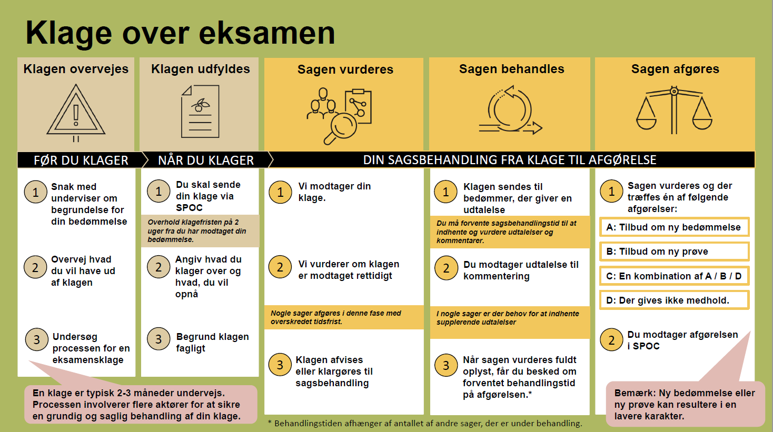

Examination appeals are handled in SAGA to ensure compliance with the GDPR legislation.
If we have asked for an opinion in several appeals, assessors will have to use the link from the most recently received auto-generated email from SPOC, from which all cases can be accessed.
We ask assessors, and others, to contact us by email (samfklager@sam.sdu.dk) or telephone (6550 4370) if they experience problems accessing the cases or have other questions about the handling of the examination appeals.

November 2022
The Legality Team, Faculty of Social Sciences and Business Administration

SUGGESTION/TEMPLATE for opinion in examination appeals
(Choose the relevant assessment among the below)
Overall, it is my/our assessment that the examination paper is an expression of a completely unacceptable performance in all aspects, which cf. the Grading Scale Order, results in the grade "-3".
Overall, it is my/our assessment that the examination paper is an expression of an insufficient performance that does not meet the minimum requirements for acceptance, which cf. the Grading Scale Order, results in the grade "00".
Overall, it is my/our assessment that the examination paper is an expression of a sufficient performance that only meets the minimum requirements for acceptance, which, cf. the Grading Scale Order, results in the grade "02".
Overall, it is my/our assessment that the examination paper is an expression of a fair performance displaying some command of the relevant material but also some major weaknesses, which, according to the Grading Scale Order, results in the grade "4".
Overall, it is my/our assessment that the examination paper is an expression of a good performance displaying good command of the relevant material but also some weaknesses, which cf. the Grading Scale Order, results in the grade "7".
Overall, it is my/our assessment that the examination paper is an expression of a very good performance displaying a high level of command of most aspects of the relevant material, with only minor weaknesses, which cf. the Grading Scale Order, results in the grade "10".
Overall, it is my/our assessment that the examination paper is an expression of an excellent performance displaying a high level of command of all aspects of the relevant material, with no or only a few minor weaknesses, which cf. the Grading Scale Order, results in the grade "12".
It appears from the subject's goal description, that students must be able to (please insert an excerpt from the goal description or the entire goal description for the subject):
• account for xxx
• reflect xxx
• xxx
(How the argumentation is written depends on how the student has formulated his/her appeal. A few examples are shown below).
(Example 1)
The student writes, as a reason for the appeal that xxx
It is also noted that xxx
(Example 2)
The following is a review of each sub-question, with reference to the student's comments in the appeal and my/our assessment of the achievement of the goal description (and possibly assigning scores to each sub-questions).
Question 1:
Question 2:
Question 3:
Summary:
(If scores are assigned to each sub-question, it would be great with a count of points, which is compared with the requirement to pass).
Overall, it is (not) my/our assessment that the examination paper fulfills the subject's goal description to xx degree, as xxx (Refer directly to what is not assessed as fulfilled, cf. the goal description. It is fine if some of this can be found in the comments to the individual sub-questions).
On this basis, I/We recommend to/not to find in favor of the complainant.

