Risk Assessment (APV) Form for Pregnant and Breastfeeding Employees

Responsibility According to the Pregnancy Policy of the Faculty of Engineering
The Head of Department is responsible for the planning and implementation of the pregnant employee's work so that there is no risk of danger to the health of the pregnant employee/the unborn child/breast-fed children. An individual written risk assessment, (Pregnancy APV) must be completed for pregnant or breastfeeding employees. The pregnant/breastfeeding employee, the Head of Department and the immediate manager are responsible for ensuring that this happens.

The pregnant employee must complete the APV in collaboration with the workplace representative and the responsible research leader/the laboratory supervisor.

Help and guidance can be provided by the Health and Safety Group, TEK’s Senior Adviser for Health & Safety, SDU's Health and Safety Team, advisers, occupational health clinic etc. Work tasks which involve risk factors may not be carried out before they have been assessed and found to be safe. If this cannot be guaranteed, the pregnant/breastfeeding employee cannot carry out the work.

Find more information in TEK’s Lab Policy for Coming and New Parents.

Registration

Name of employee
Department/Unit
Group
Head of Department
Head of Unit
Laboratory supervisor
Health and safety representative
Proposed solution prepared by
Date

Ergonomic Conditions
Your answers must take all of your workplaces into account (e.g., office, laboratory, technical room, workshop, classroom, fieldwork)

Does your work involve strenuous positions, repetitive physical work, heavy lifting or pushing?

yes no
- Sedantary work with limited options for varying work position
- Standing work with limited options for varying work position
- Long periods of strenuous repetitive work movements; static muscle work
- Strenuous working positions, such as twisting and stretching
- Lack of knowledge about good and varied work positions
- Heavy lifting
- Frequent lifting
- Long periods of lifting and carrying
- Pushing and pulling heavy objects
- Climbing ladders or similar
- Other

If yes, is the work related to:

Description of problem:
Proposed solution:

Chemical and Biological Effects
Your answers should include all your work functions (e.g. laboratory work, practical work, service function)

Do you work with chemical or biological agents?

yes no

If yes, is the work related to:
- Chemicals marked H310, H311, H312, H340, H341, H350, H350i, H351, H360, H361, H362, H370, H371, H372, H373
- Carcinogens
- Hormone disruptors
- Airborne substances or organic solvents
- Lead or lead compounds
- Pesticides
- Heavy metals
- Anaesthetic or asphyxiating gases
- Chemicals that are absorbed through the skin
- Radioactive materials/substances
- Biological agents; e.g., blood and tissue samples
- Other__________________________________

If you answer yes to any of the points above, a chemical risk assessment (APV) of your work tasks must be completed.
The form is available on page 5 of this Pregnancy APV.

REMEMBER:
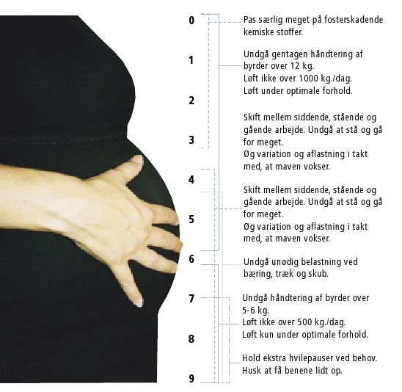
Pregnancy months:
Take special care with teratogenic chemicals.

Avoid handling of objects over 10 kg.
Do not lift more than 1000 kg per day.
Lift only when conditions are optimal.

Alternate between work that involves sitting, standing, and walking. Avoid standing and walking too much.
Increase variation and relief in line with the growth of the stomach.

Alternate between work that involves sitting, standing, and walking. Avoid standing and walking too much.
Increase variation and relief in line with the growth of the stomach

Avoid unnecessary strain when carrying, pulling, and pushing.

Avoid handling objects over 5-6 kg.
Do not lift over 500 kg per day.
Lift only when conditions are optimal.

Take extra breaks as required.
Remember to put your feet up.

Important H Phrases:

- H310 Fatal in contact with skin.  - H311 Toxic in contact with skin.  - H312 Harmful in contact with skin.  - H340 May cause genetic defects.  - H341 Suspected of causing genetic defects.  - H350 May cause cancer.  - H350i May cause cancer by inhalation.  - H351 Suspected of causing cancer.  - H360 May damage fertility or the unborn child. | - H361 Suspected of damaging fertility or the unborn child.  - H362 May cause harm to breast-fed children.  - H370 Causes damage to organs.  - H371 May cause damage to organs.  - H372 Causes damage to organs through prolonged or repeated exposure.  - H373 May cause damage to organs through prolonged or repeated exposure.

Chemical Risk Assessment

Description of the work area covered by the risk assessment - e.g. research in organic polymers, practice course no. xxxx, name of process, course, etc.

When relevant, you can – as part of the risk assessment – include existing chemical risk assessment(s).

Date: _________________________________________________

Employee (signature): _______________________________________

Responsible chemist (signature): _______________________________________

Responsible manager (signature): _______________________________________

Health & Safety representative (signature): ________________________________

DESCRIPTION OF WORK PROCESS
The description can take the form of a flow diagram of the process - i.e. division into logical sub-processes.

CHEMICALS

List chemicals/substances/biological agents/animal by-products used here.

SIGNIFICANT DANGER FROM CHEMICALS/OTHER MATERIALS

Only harmful substances should be included. The substances' harmful characteristics and type of exposure must be described - e.g. toxic if inhaled, causes cancer in contact with the skin, flammable, etc. The quantity must be indicated if it’s significantly different from ordinary laboratory work.

SIGNIFICANT DANGER FROM WORK PROCESS
E.g. lasers, vacuum, mixing of chemicals, other equipment - e.g. glass equipment used for vacuum with risk of explosion.

RISK OF EXPOSURE

Evaluate the real risk in relation to the work process. That chemicals are harmful if inhaled does not mean that there is a risk of inhalation during a particular work process. Consider where in the work process the relevant risk is present - whether it is during the whole work process or only in a sub-process. Remember the entire process from preparation through to clearing up after the completed process and disposal of waste.

SUBSTITUTION OPTIONS

Account for what has been tried and considered in relation to substitution of dangerous chemicals or work processes. Remember that substitution also includes using small amounts instead of large amounts.

NECESSARY SAFETY PRECAUTIONS
Ventilation | Fume cupboard:  Fume extractor:  LAF Cabinet:  Other:  Is the specified equipment required throughout the entire work process or only in parts? Describe:
Chemical protection gloves  (indicate approximate breakthrough time if possible) | Type:  Breakthrough time:  Is the specified equipment required throughout the work process or only in parts? Describe:
Other personal protective equipment | Lab coat:__________________________________________________  Safety glasses:_____________________________________________  Breathing equipment (indicate Filter): _____________________________________________  Special footwear (indicate type):  _____________________________________________  Other:__________________________________________________  Is the specified equipment required throughout the work process or only in parts? Describe:
Other safety precautions | Special heat source with fire hazard:_______________  Other:__________________________________
Special emergency equipment | Special fire extinguishers:_________________________________  Antidote (if applicable):___________________________________  Other:_________________________________________________

Special education/training or instruction: | Statutory education/training:______________  Instruction in the use of particularly hazardous equipment:  Other:

WHAT SHOULD BE DONE IN THE EVENT OF AN ACCIDENT OR SPILLAGE?
Describe the action to be taken in the event of a relevant accident, clean-up and removal of spillages, accident procedures, etc.

WASTE
Instructions for labelling waste canisters – which waste group, UN number, etc. – optional short description detailing that the waste will be delivered to the chemical waste representative (name).

PREGNANT AND BREASTFEEDING EMPLOYEES
Is the work process/area safe for pregnant and breastfeeding employees??
Yes__________ reason:_____________________________________
No_________ reason:_____________________________________
PROPOSALS FOR IMPROVEMENTS TO SAFETY:
This point is intended to provide input for an overall APV for the department/section.

