Guide to booking rooms and invigilators for exams in Odense

Go to the Teams site below
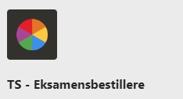
TS – Exam organisers | General | Microsoft Teams

If you don’t have access, please email eksamensvagt@sdu.dk and we will grant you access.

Once you have access, enter the site and click ‘Files’.

Here you will find folders with the ongoing exam periods or those for which you can make bookings. There is one folder for the written exams and one for the oral exams per month.
In addition, general information will also be available here.
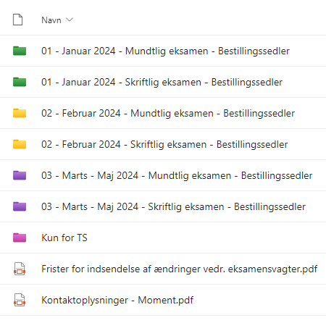

The major exam months of January, February, June and August each have their own folders. This is because there is a single booking deadline for the entire month.

Please find the deadlines for booking here:
SDUnet – Exam support

The order form looks like the one below:
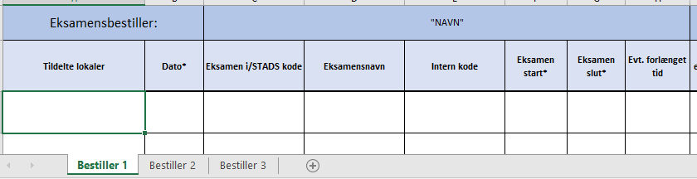
Find the tab with your name on it. If it’s not listed, please email eksamensvagt@sdu.dk and we’ll create it for you.
We make sure to fill in the ‘Assigned rooms’ column, which lists which rooms are assigned.
You must fill in the other columns (those marked with an asterisk (*)) in the form.

