Exhibition purpose of the teaching portfolio
For the exhibition purpose, the four elements are used: Teaching experience, Pedagogical education, Other pedagogical qualifications and Teaching philosophy.
Teaching experience:
The lecturer tabulates relevant previous experience (e.g. breadth, level, scope, role, number of students) in a clear and easy-to-read way.
For example, the table can have the following format: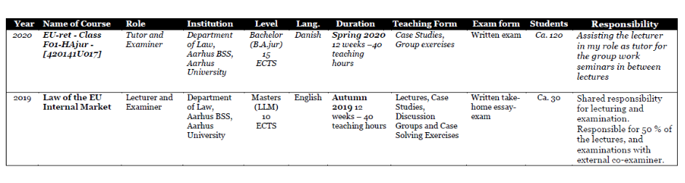
Short summary:
Pedagogical education:
The lecturer tabulates formal pedagogical education and completed pedagogical courses.

Other pedagogical qualifications:
The lecturer describes pedagogical collaboration, pedagogical leadership, and pedagogical knowledge exchange that has helped develop own and/or colleagues' pedagogical skills.
Teaching philosophy:
The lecturer describes his or her own teaching values. For example, the lecturer may seek to answer these questions:
- What are the most important 1-2 overall pedagogical goals of my teaching (what) (e.g. promoting critical thinking, active learning, individualised learning, ownership, motivation, students' personal development, societal relevance, social change, classical knowledge, bildung, research-based teaching, etc.)
- How do I therefore generally teach (how)?
- Why do I teach in this particular way (why)?
- To what extent do I achieve the pedagogical goals of my teaching (results)?

