Assessment purposes of the teaching portfolio
In recruitment and assessment situations, all elements of the portfolio are used. A complete teaching portfolio is expected to be 6-8 pages plus any appendix material.
Teaching portfolio at SDU
Name:
Date:

Teaching experience:
The lecturer tabulates relevant previous experience (e.g. breadth, level, scope, role, number of students) in a clear and easy-to-read way.
For example, the table can have the following format: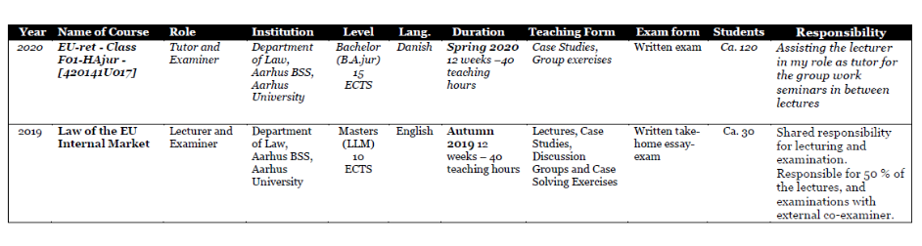
Short summary:
Pedagogical education:
The lecturer tabulates formal pedagogical training and completed pedagogical courses.

Other pedagogical qualifications:
The lecturer describes pedagogical collaboration, pedagogical leadership, and pedagogical knowledge exchange that has helped develop own and/or colleagues' pedagogical skills.
Teaching philosophy:
The lecturer describes his or her own teaching values. For example, the lecturer may seek to answer these questions:
- What are the most important 1-2 overall pedagogical goals of my teaching (what) (e.g. promoting critical thinking, active learning, individualised learning, ownership, motivation, students' personal development, societal relevance, social change, classical knowledge, bildung, research-based teaching, etc.)
- How do I therefore generally teach (how)?
- Why do I teach in this particular way (why)?
- To what extent do I achieve the pedagogical goals of my teaching (results)?
Reflective practice - examples of teaching sequences:
The lecturer
- describes 1-2 specific, purpose-selected, relevant examples of courses or teaching sequences that the lecturer has conducted

- justifies his/her didactical choices,

- describes the results/effects of his/her teaching and

- critically evaluates experiences and results.
The reflection leads to a synthesis of necessary developments for the future.
Development activities:
The lecturer describes 1-2 selected examples of teaching or curriculum development that have been carried out (e.g. course development, curriculum development, study board work, etc.), justifies the pedagogical choices and assesses results and effects.
Evidence:
The lecturer attaches evidence for key claims in the portfolio as an appendix and references them in the portfolio (e.g. course evaluations, testimonials, evidence, course materials, etc.).

